How to Submit a DAS ticket
There is no form to fill out when emailing DAS to Support@dasmsp.com
I have created an example below. Copy and Paste this table below into an email addressed to DAS

Full Name -
Site And Location
Your Email address –
Your Best Contact #
When available to take a call – | From To
Requesting for another user: Their Name
Their Email address:
Computer Name – if known
Brief Summary of Request-
Action taken on my part – | I restarted the computer,
Add a Screen Shot (photo)
Priority – Not urgent

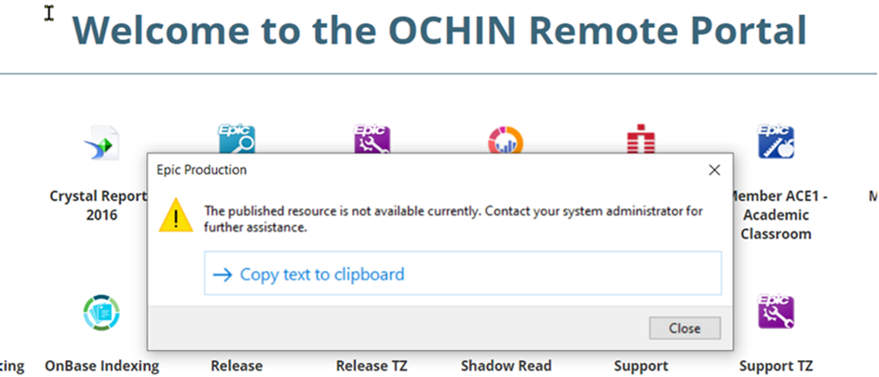

Include any pictures of the any errors

Full Name: | Jacqueline Giron
Site And Location | Shotwell Optometry
Email address: | jacgir@mnhc.org
Best Contact# | 415-451-4152
When available to take a call: | 9 am to 12 pm 1 pm to 5 pm
Computer Name: | D12345
Brief Summary: | When I launch EPIC, I get this strange error – see the photo attached.
Action taken on my part: | I tried to restart the computer and I got the same error.
Screen Shot ( If applicable): | see attached
Priority: | Not Urgent

